**Assignment 1**

Laney Light, Tejas Manjunath, Amy Hung

1. **Evaluation of pitch tracker with test signal**

The pitch tracker calculated the fundamental frequency correctly as 441 Hz from 0 to 1 second, and 882 Hz from 1 to 2 seconds (see Figure 1). However, the error was 441 Hz at the 1 second mark, as seen in Figure 2. The pitch tracker calculated the frequency incorrectly for 1 block that crossed the 1 second mark because the pitch changed during that block. The block duration was from approximately 0.998 sec to 1.022 sec, so most of the block contained the 882 Hz test signal, and the tracker assigned a frequency of 882 Hz to the entire block.

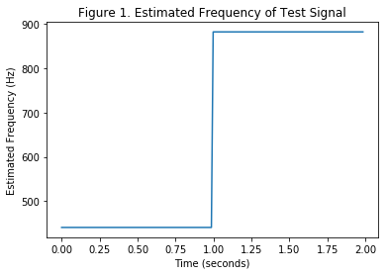

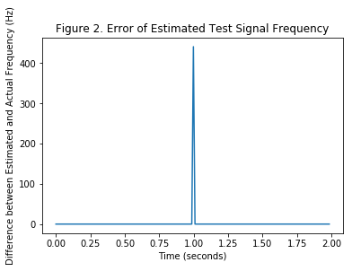

1. **Evaluation of pitch tracker with “Mairena” dataset**